**Equip9 Assessment**

**Name**: Yash Nathe  
**Email**: yashnathe2001@gmail.com  
**Mobile Number**: 7058088965  
**Date**: 31-12-2024

**Task Part 1:**

Develop an HTTP service in any programming language of your choice. The service should expose the following endpoint.

**Steps:**

**Step 1: Create an S3 Bucket**

1. Log in to the AWS Management Console.
2. Choose the S3 service.
3. Click on the **Create bucket** option.
   * **Select AWS Region**: I chose **ap-south-1 (Mumbai)**.
   * **Bucket Name**: myequip9-task.
4. Click **Create bucket** to finalize.

**Step 2: Configure AWS CLI with Access Token**

1. Generate an **Access Key** and **Secret Key** for your AWS user:
   * Go to the AWS Management Console and navigate to **IAM (Identity and Access Management)**.
   * Under **Users**, select your username and create new access keys.
2. Configure the AWS CLI:



Enter the **Access Key**, **Secret Key**, **Region (ap-south-1)**, and default output format (e.g., json).

**Step 3: Upload the Directory and Files Structure**

1. **Prepare the Directory and File Structure:**  
   Locally create the following structure:

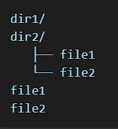

1. **Upload to S3 Bucket:**

* **For Directories (dir1 and dir2):**  
  Use the following AWS CLI command:

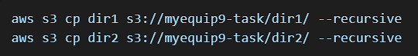

* **For Files (file1 and file2):**  
  Use the following AWS CLI command:

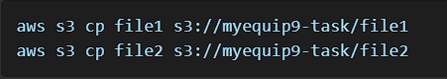

**Command Explanation:**

* **cp**: The AWS CLI command to copy files to/from S3.
* **--recursive**: Ensures all subdirectories and their contents are uploaded.
* **<bucket-name>**: Replace with the actual name of your S3 bucket (e.g., myequip9-task).

1. **Verify Upload:** After uploading, confirm the structure in the bucket by running:



**Step 4: Develop the HTTP Service**

1. **Install Required Libraries:**  
   Install Flask and Boto3 for Python:



1. **Write the Code:** Save the following script as app.py:

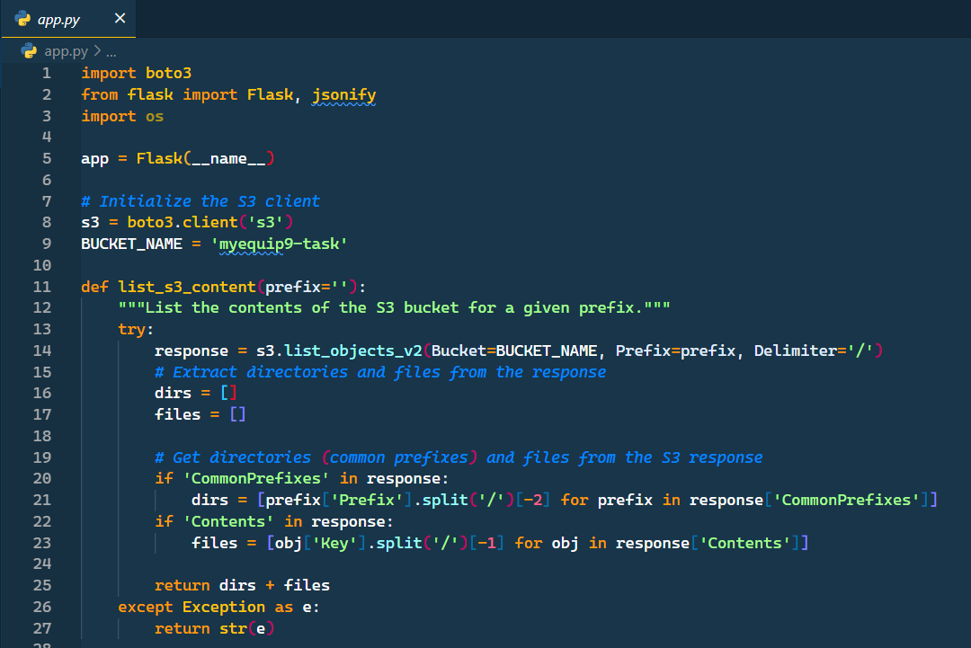

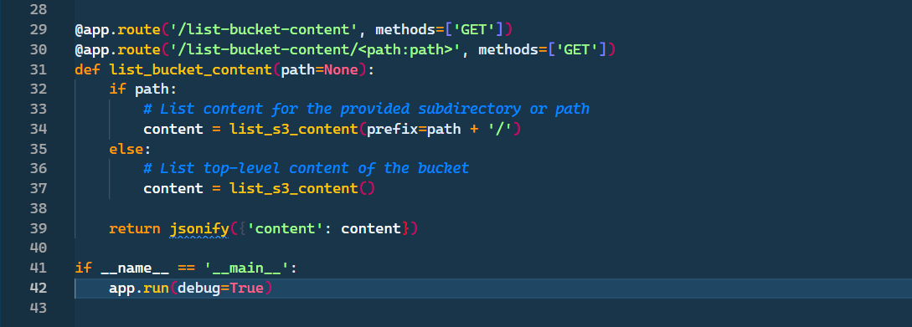

1. **Run the Application:**



1. **Test the Application:**

* Use Postman or Curl to test the endpoints:
* **Top-Level Content:**

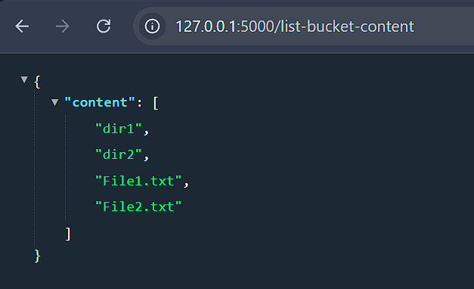

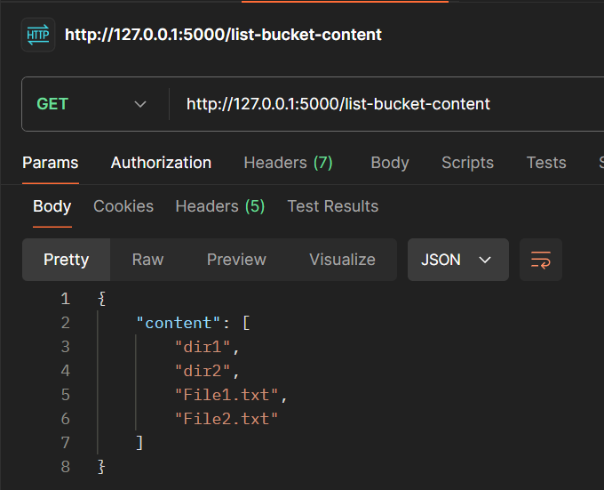

* Specific Directory (e.g., dir1 and dir2)

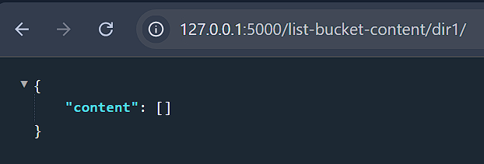

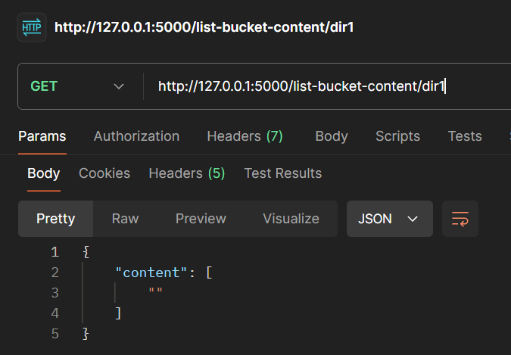

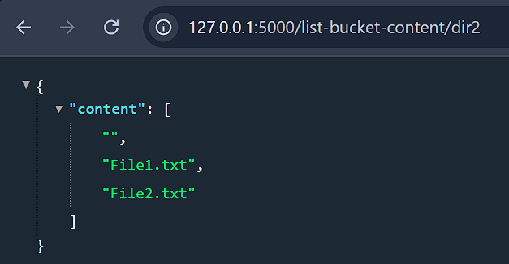

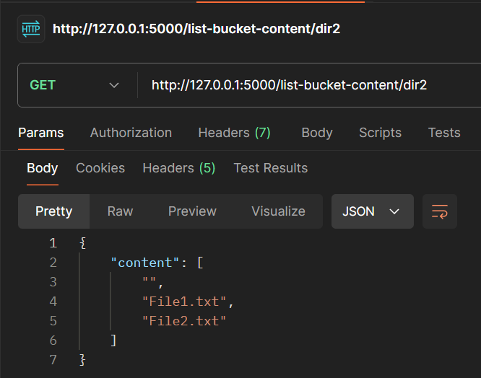

1. **Request:** GET /list-bucket-content  
   **Response:** { "content": ["dir1", "dir2", "file1", "file2"] }
2. **Request:** GET /list-bucket-content/dir1  
   **Response:** { "content": [] }
3. **Request:** GET /list-bucket-content/dir2  
   **Response:** { "content": ["file1", "file2"] }